**Comprehensive Analysis of Superstore Sales: Revenue Breakdown by Region, State, and Product Category**

**Project Overview**

From the dataset, we have approximately 22 columns that can help us analyse and answer many questions regarding the sales performance of the superstore. For this project, our focus is on understanding the total revenue generated by the superstore, categorizing revenue by regions and states, and identifying which product categories sold the most in each region and state.

**Abstract**

This report presents a comprehensive analysis of the superstore's sales data, aimed at uncovering key insights into revenue generation, product performance, and customer demographics. Utilizing Excel for initial data cleaning and Power BI for advanced data transformation and visualization, we created a detailed dashboard comprising 12 charts. The analysis revealed that the West region, particularly California, is the highest revenue-generating area. Technology products lead in revenue, while Office Supplies account for the highest sales volume. Further, the West region dominates sales across all product categories, with significant demand in Technology and Furniture as well. The top-selling product is the Canon ImageCLASS 2200 Advanced Copier, indicating a strong market for office equipment. Additionally, the customer base predominantly consists of consumers rather than corporate clients. These findings provide actionable insights, suggesting strategic opportunities to enhance marketing efforts, expand product offerings, and target both small businesses and potential corporate clients to drive sustained growth.

**Introduction**

**Problem Statement**

The superstore has accumulated extensive sales data, yet there is a lack of comprehensive analysis to extract actionable insights from this data. Specifically, the store management needs to understand the overall revenue performance, identify which regions and states generate the most revenue, and determine the top-selling product categories in each area. This analysis is crucial for informed decision-making, optimizing inventory, and tailoring marketing strategies to boost sales and profitability.

**Objectives**

* Total Revenue Analysis: Calculate and analyse the total revenue generatedby the superstore to gain a clear picture of overall sales performance.
* Regional and State Revenue Categorization: Break down the revenue by regions and states to identify high-performing and underperforming areas.
* Product Category Analysis: Determine the best-selling product categories in each region and state to understand consumer preferences and trends.
* Data-Driven Insights: Provide actionable insights and recommendations based on the analysis to help the superstore improve sales strategies and operational efficiency.

**Methodology**

The dataset's origin is unknown, but it was obtained in Excel format. The initial step in our analysis involved data cleaning using Excel. This process included checking for and removing blank entries, eliminating duplicates, and standardizing text formatting.

**Tools Utilized**

The primary tools used for this analysis were Excel and Power BI. Excel was employed for initial data cleaning and preparation, while Power BI was used for advanced data transformation and dashboard creation.

**Stages of Creating the Dashboard**

**Stage I: Data Cleaning in Excel**

The first stage involved a thorough data cleaning process in Excel. This included identifying and removing blank entries, eliminating duplicate records, and standardizing text formatting to ensure data consistency and accuracy. Once cleaned, the data was prepared for transformation.

**Stage II: Data Transformation in Power Query**

In the second stage, the cleaned data from Excel was imported into Power Query within Power BI. Here, further transformations were performed to refine the dataset. This involved:

* **Identifying Key Columns:** Pinpointing columns containing crucial values, such as revenue figures, product categories, region and state identifiers, customer segments, and dates.
* **Categorizing Data:** Assigning appropriate categories to data columns to facilitate more effective analysis and visualization.
* **Date Formatting:** Ensuring that date columns were correctly formatted for time-based analysis, such as trend identification and seasonal performance assessment.

These steps ensured that the data was well-structured and ready for the creation of a dynamic and informative dashboard.

**Stage III: Objectives of the Analysis**

The objectives for the analysis were established as follows, with the aim of creating a comprehensive dashboard to display critical insights:

1. **Total Revenue by Region**: Display the total and percentage revenue generated from each region.
2. **Total Revenue by State**: Identify which states have the highest number of customers and total revenue.
3. **Total Revenue by Product Category**: Determine which product categories are the top sellers.
4. **Total Number of Products Sold by Region**: Show the total and percentage number of products sold in each region.
5. **Total Number of Products Sold by State**: Present the number of products sold in each state.
6. **Total Number of Products Sold by Product Category**: Indicate the total number of products sold within each category.
7. **Percentage of Product Types Sold per Region**: Display the percentage breakdown of product types sold in each region.
8. **Revenue Percentage of Product Types per Region**: Show the revenue percentage of each product type in different regions.
9. **Product Categories by Customer Segment**: Analyse which customer segments purchase specific product categories.
10. **Total Number of Product Types Sold per State**: Show the total number of different product types sold in each state.
11. **Total Revenue per Product Name**: Display the revenue generated by individual products.
12. **Total Revenue per Customer Segment**: Indicate the total revenue contributed by each customer segment.

By establishing these objectives, the dashboard will provide a detailed overview of the store’s revenue performance across regions, states, product categories, and customer segments, allowing for more informed decision-making.

**Stage IV: Dashboard Creation**

In this stage, the focus was on creating a comprehensive and user-friendly dashboard using Power BI. This tool was selected for its robust data visualization capabilities and ease of use. The primary visual elements incorporated into the dashboard were pie charts and bar charts, chosen for their effectiveness in displaying percentages and making data easily comprehensible. These visualizations were employed to represent various metrics such as total revenue by region, state, and product category, as well as the distribution of product sales and customer segments. The goal was to ensure that the dashboard provided clear, actionable insights at a glance.

**Conclusion**

By following these structured stages, we ensured that the data was thoroughly prepared and transformed to provide accurate and meaningful insights. The initial data cleaning in Excel established a reliable foundation, while the subsequent transformations in Power Query enabled us to organize and categorize the data effectively. The final step of creating the dashboard in Power BI allowed us to present the analysis in an accessible and visually appealing manner, using intuitive charts to facilitate easy comprehension. This meticulous approach ensured the integrity of the data and the clarity of the insights derived, laying a robust groundwork for the subsequent analysis and interpretation of the superstore’s sales performance.

**Results**

The final dashboard was created to visually represent the key findings of the analysis. It includes 12 distinct charts, each corresponding to the specific objectives outlined in the methodology section. These charts collectively provide a comprehensive overview of the superstore's sales performance, delivering detailed insights into various aspects such as total revenue, product sales, and customer segments across different regions and states. The visualizations are designed to make complex data easily interpretable, enabling stakeholders to make informed decisions based on clear and concise information.

**THE DASHBOARD**

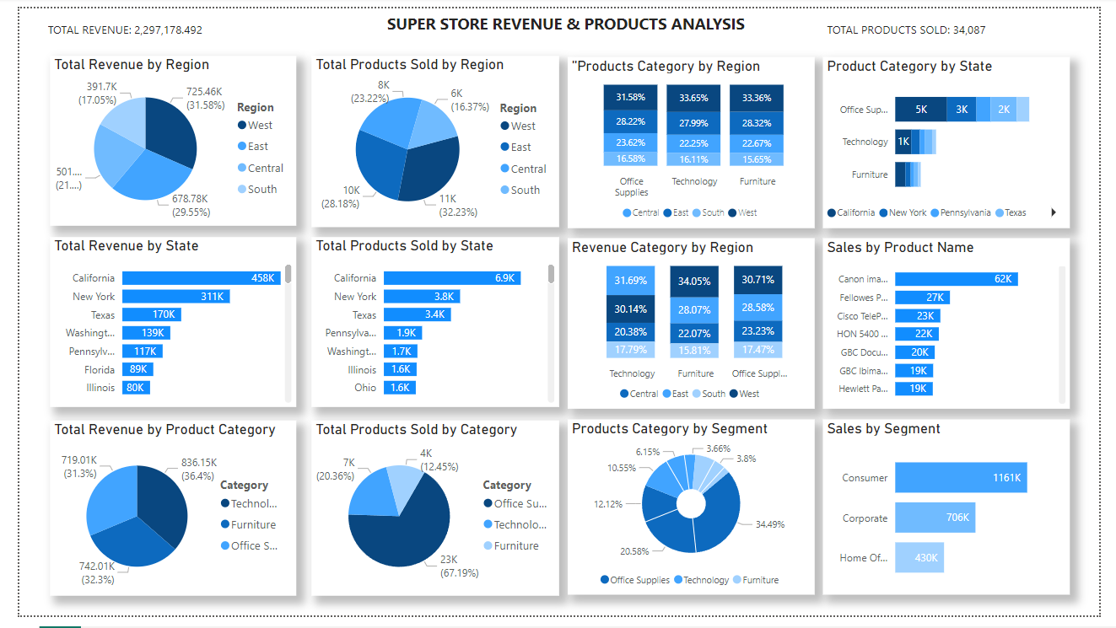

**Key Findings from the Dashboard**

The dashboard provides a detailed visualization of the superstore's sales performance, highlighting several key findings:

1. **Highest Revenue Region and State**: The region generating the highest revenue is the West, with California being the top-performing state in terms of revenue.
2. **Top Product Category by Revenue**: Technology products lead in revenue generation across all regions.
3. **Product Sales Volume**: The West region not only has the highest revenue but also the highest number of products sold, mirroring California's state-level performance.
4. **Sales by Product Category**: Although Technology products bring in the most revenue, Office Supplies dominate in terms of sales volume, accounting for 67.19% of total sales.
5. **Regional Sales Breakdown**: The West region shows the highest sales across all three major product categories:
   * Office Supplies: 31.56%
   * Technology: 33.65%
   * Furniture: 33.36%
6. **State-Level Product Sales**: Office Supplies are the most sold category in most states.
7. **Top-Selling Product**: The Canon ImageCLASS 2200 Advanced Copier is the best-selling product, with approximately 62,000 units sold.
8. **Customer Segmentation**: The store's customer base consists predominantly of consumers rather than corporate clients.

These findings provide actionable insights into the superstore's sales dynamics, revealing critical trends and opportunities for targeted marketing and inventory management.

**Discussion**

The analysis of the superstore's sales data has yielded several important insights, which are critical for understanding the current market dynamics and guiding future business strategies.

**Revenue and Sales Distribution**

The West region emerges as the most lucrative area for the superstore, both in terms of revenue and volume of products sold. California stands out as the highest-revenue state, indicating a strong customer base and effective market penetration in this region. This suggests that the superstore’s marketing and operational strategies are particularly effective in the West, possibly due to a combination of higher population density, greater purchasing power, and targeted promotional efforts.

**Product Category Insights**

The finding that Technology products generate the highest revenue is significant, highlighting the importance of these products to the superstore’s overall profitability. However, Office Supplies, despite generating less revenue, account for the highest volume of sales at 67.19%. This disparity suggests that while Technology products have higher price points and contribute more per unit sold, Office Supplies are essential for driving frequent customer visits and sustaining steady sales.

The dominance of Office Supplies in sales volume also underscores the potential for upselling and cross-selling opportunities. By understanding that customers frequently purchase Office Supplies, the superstore can strategically position Technology and Furniture products to these buyers, thereby increasing overall sales.

**Regional and State Performance**

The West region's strong performance across all product categories indicates a balanced demand for diverse product types in this area. The data reveals that the West region not only leads in Office Supplies but also shows substantial sales in Technology and Furniture, with percentages closely aligned (31.56%, 33.65%, and 33.36%, respectively). This balanced demand profile suggests that marketing efforts in the West should continue to emphasize a wide range of products.

At the state level, the fact that Office Supplies are the top-selling category suggests a broad base of small businesses and home offices. The superstore can capitalize on this trend by offering bundled deals or loyalty programs aimed at small business owners and office managers.

**Top-Selling Products and Customer Segmentation**

The Canon ImageCLASS 2200 Advanced Copier being the highest-selling product with approximately 62,000 units highlights the demand for reliable office equipment. This points to an opportunity for the superstore to expand its range of high-quality office technology products and offer complementary services such as maintenance packages or extended warranties.

Finally, the predominance of consumer customers over corporate clients suggests that the superstore's current appeal is more towards individual buyers and small businesses rather than large enterprises. To tap into the corporate market, the superstore might consider developing targeted marketing campaigns, expanding its range of bulk purchase options, and offering tailored services to meet the needs of larger businesses.

**Strategic Implications**

Based on these findings, several strategic actions can be recommended:

1. **Strengthen Marketing in the West**: Continue to focus marketing efforts in the West region, leveraging the established customer base to introduce new products and services.
2. **Expand Technology and Office Supplies Offerings**: Given the high revenue from Technology products and the sales volume of Office Supplies, expanding these categories with new and innovative products could drive further growth.
3. **Target Small Businesses**: Develop targeted marketing strategies and loyalty programs aimed at small businesses and home office users to enhance customer retention and increase sales.
4. **Explore Corporate Opportunities**: Investigate opportunities to attract corporate clients by offering bulk purchase options, corporate accounts, and specialized services.

In conclusion, the superstore is well-positioned to leverage these insights to optimize its product offerings, enhance customer satisfaction, and drive sustained growth across its markets.

**Conclusion**

The comprehensive analysis of the superstore's sales data has provided valuable insights into its revenue streams, product performance, and customer segmentation. The West region and California, in particular, stand out as top performers, underscoring the effectiveness of current strategies in these areas. Technology products lead in revenue generation, while Office Supplies dominate in sales volume, highlighting different opportunities for maximizing profitability and customer engagement.

These findings reveal significant opportunities for the superstore to refine its strategies. By focusing on high-performing regions and states, expanding popular product categories, and developing targeted marketing campaigns for small businesses and potential corporate clients, the superstore can enhance its market presence and drive growth.

The key takeaways from this analysis include:

1. **Geographic Focus**: Strengthen marketing and operational efforts in the West region and California.
2. **Product Strategy**: Expand offerings in Technology and Office Supplies to capitalize on their respective strengths in revenue and sales volume.
3. **Customer Engagement**: Develop tailored programs and campaigns to attract and retain small business customers and explore opportunities in the corporate sector.

By leveraging these insights, the superstore can make data-driven decisions to optimize its inventory, improve customer satisfaction, and achieve sustained growth in a competitive market.